**1) Installing Minikube (K8s)** 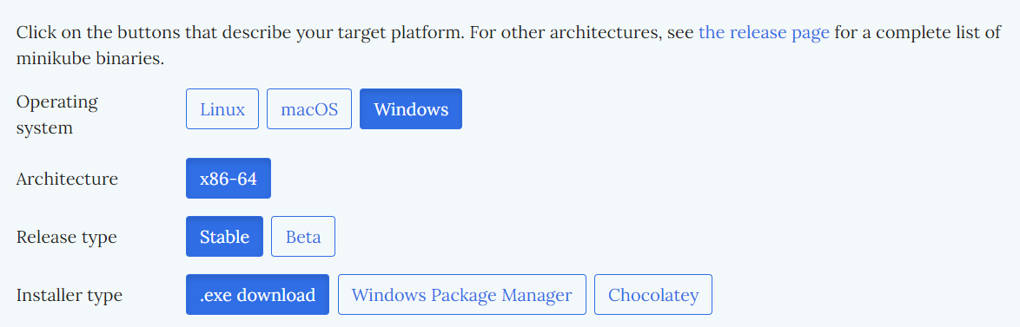

* **Go to minikube official website to choose the configuration**

**To install the latest minikube stable release on x86-64 Windows using .exe download:**

* **Using CMD, Execute this command :**

**New-Item -Path 'c:\' -Name 'minikube' -ItemType Directory -Force**

**Invoke-WebRequest -OutFile 'c:\minikube\minikube.exe' -Uri 'https://github.com/kubernetes/minikube/releases/latest/download/minikube-windows-amd64.exe' -UseBasicParsing**

* **The File will be created in the give Path**
* **Open powershell in the Installed path (make sure to run as administrator), Execute Command :**

**$oldPath = [Environment]::GetEnvironmentVariable('Path', [EnvironmentVariableTarget]::Machine)**

**if ($oldPath.Split(';') -inotcontains 'C:\minikube'){ `**

**[Environment]::SetEnvironmentVariable('Path', $('{0};C:\minikube' -f $oldPath), [EnvironmentVariableTarget]::Machine) `**

**}**

Minikube will be installed.

To check wether minikube is installed? Execute command - ***Minikube version***

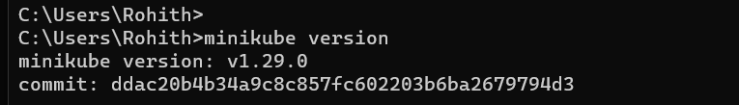

**2) Creating Deployment (pod & Services)**

* To start Minikube execute command

***~ Minikube start***

* Creating Ngnix Deployment

**kubectl create deployment nginxnew --image=nginx:1.14.2 --port=80**

Name => nginxnew (self-descriptive name)

-- Image => Name of the image and its version

-- Port => Defaut port no. of nginx server

To check the Deployment :

***~ Kubectl get deployments***

To check the Pod :

***~ kubectl get pod***

=>The Output is similar to :

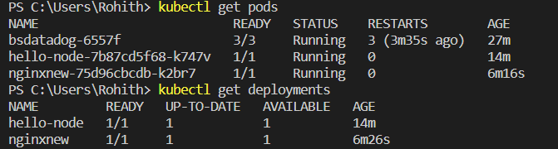

By default, the Pod is only accessible by its internal IP address within the Kubernetes cluster. To make the (nginxnew) Container accessible from outside the Kubernetes virtual network, you have to expose the Pod as a Kubernetes Service.

* Creating Service to the (Nginxnew) Pod

**kubectl expose deployment nginxnew --type=LoadBalancer --port=80**

The (--type=LoadBalancer) flag indicates that you want to expose your Service outside of the cluster.

To check the service :

***~ kubectl get services***

=> Output is similar to :

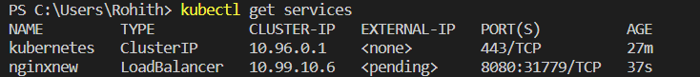

* To Start the Service & Redirect to the webpage, Execute Command:

***~ Minikube Service <servicename> nginxnew***

Output After Redirecting:

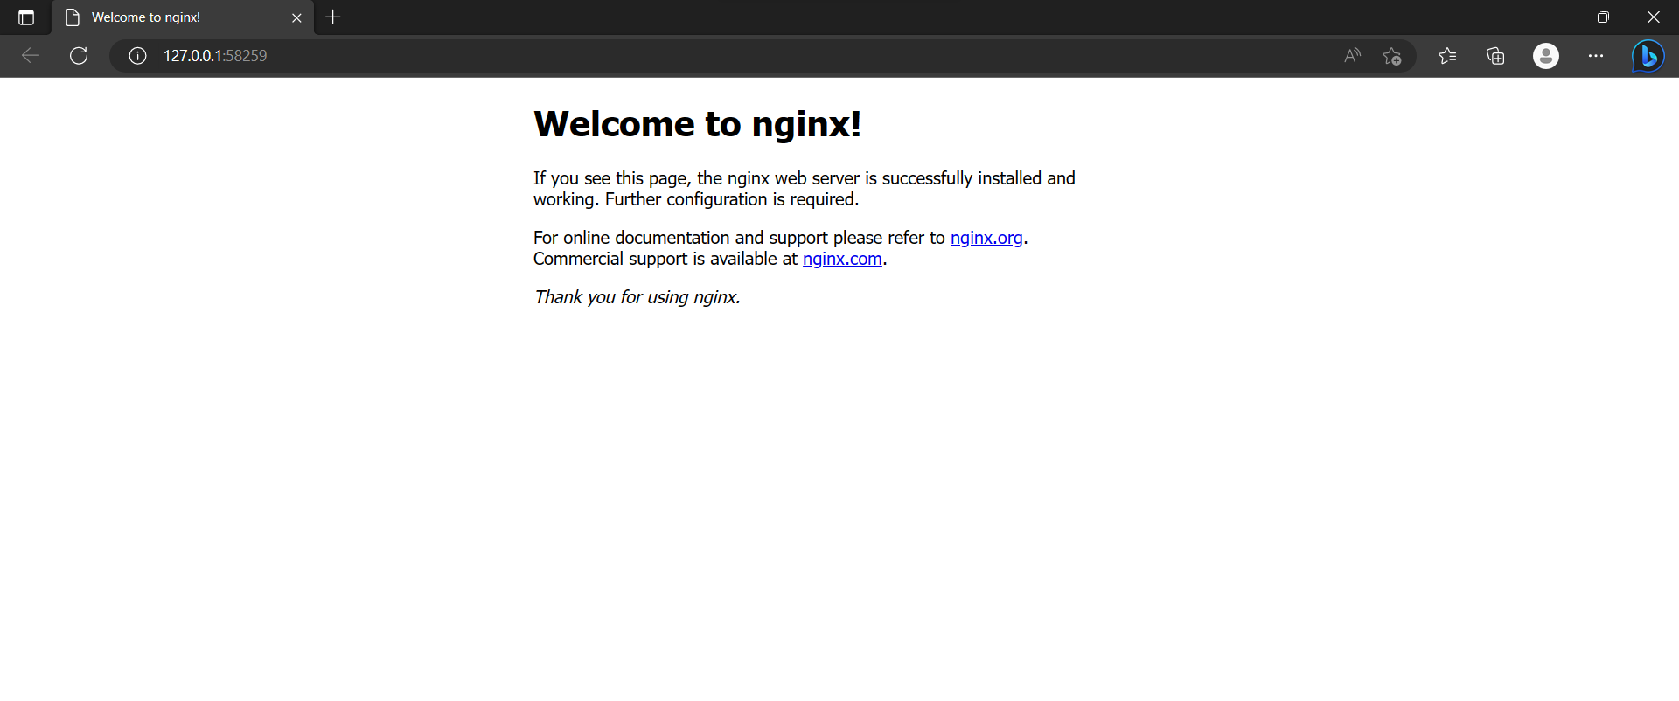

**3)Creating Pods Using YAML files (Mongo DB & UI)**

* **Required YAML files**
* MongoDB (deployment)
* MongoDB-service (Service)
* Mongo Express (deployment)
* Mongo Express-Service (service)
* Config-map
* Secrets

apiVersion: apps/v1

kind: Deployment

metadata:

  name: mongodb-deployment

  labels:

    app: mongodb

spec:

  replicas: 3

  selector:

    matchLabels:

      app: mongodb

  template:

    metadata:

      labels:

        app: mongodb

    spec:

      containers:

      - name: mongodb

        image: mongo

        ports:

        - containerPort: 27017

        env:

          - name: MONGO_INITDB_ROOT_USERNAME

            valueFrom:

              secretKeyRef:

                name: mongodb-secret

                key: mongo-root-username

          - name: MONGO_INITDB_ROOT_PASSWORD

            valueFrom:

              secretKeyRef:

                name: mongodb-secret

                key: mongo-root-password

MongoDb Deployment

<= YAML File

1. Apply the MongoDB deployment YAML file:

***kubectl apply -f mongodb.yaml(filename)***



**-----------------------------------------------------------------------------------------------**

apiVersion: v1

kind: Service

metadata:

  name: mongodb-service

spec:

  selector:

    app: mongodb

  ports:

    - protocol: TCP

      port: 27017

      targetPort: 27017

MongoDb Service

<= YAML File

1. Apply the MongoDB Service YAML file:

***kubectl apply -f mongodb-service.yaml(filename)***

**------------------------------------------------------------------------------------**

apiVersion: apps/v1

kind: Deployment

metadata:

  name: mongo-express

  labels:

    app: mongo-express

spec:

  replicas: 3

  selector:

    matchLabels:

      app: mongo-express

  template:

    metadata:

      labels:

        app: mongo-express

    spec:

      containers:

      - name: mongo-express

        image: mongo-express:0.54.0

        ports:

        - containerPort: 8081

        env:

          - name: ME_CONFIG_MONGODB_ADMINUSERNAME

            valueFrom:

              secretKeyRef:

                name: mongodb-secret

                key: mongo-root-username

          - name: ME_CONFIG_MONGODB_ADMINPASSWORD

            valueFrom:

              secretKeyRef:

                name: mongodb-secret

                key: mongo-root-username

          - name: ME_CONFIG_MONGODB_SERVER

            valueFrom:

              configMapKeyRef:

                name: mongodb-configmap

                key: database_url

Mongo-express Deployment

<= YAML File

1. Apply the MongoExpress deployment YAML file:

***kubectl apply -f mongo-express.yaml(filename)***

**-------------------------------------------------------------------------------------------------------------**

apiVersion: v1

kind: Service

metadata:

  name: mongo-express-service

spec:

  selector:

    app: mongo-express

  type: LoadBalancer

  ports:

    - protocol: TCP

      port: 8081

      targetPort: 8081

      nodePort: 30000

Mongo-Express

Service

<= YAML File

1. Apply the MongoExpress Service YAML file:

***kubectl apply -f mongo-express-service.yaml(filename)***



**-----------------------------------------------------------------------------------------------**

apiVersion: v1

kind: ConfigMap

metadata:

  name: mongodb-configmap

data:

  database_url: mongodb-service

MongoDb

Config-map

<= YAML File

1. Apply the Configmap YAML file:

***kubectl apply -f mongo-ConfigMap.yaml(filename)***

**-----------------------------------------------------------------------------------------------**

**-----------------------------------------------------------------------------------------------**

apiVersion: v1

kind: Secret

metadata:

  name: mongodb-secret

type: Opaque

data:

  mongo-root-username: dXNlcm5hbWU=

  mongo-root-password: cGFzc3dvcmQ=

MongoDb

Secret

<= YAML File

1. Apply the Secrets YAML file:

***kubectl apply -f mongo-secret.yaml(filename)***

**-----------------------------------------------------------------------------------------------**

* To Apply All the Files In the folder at a time:

***kubectl apply .***

( . ) Indicates that All files

**-----------------------------------------------------------------------------------------------**

* **To redirect to the webpage :**

***~ Minikube Service <servicename> Mongo-express-service***

**-----------------------------------------------------------------------------------------------**

* Every YAML file Consists of appVersion , kind, Metadata, Specifications.
* And also Volumes, Port Numbers, ENV variables, Images are Defined.
* Config-map Contians non- confidential data.
* Secret file stores Confidential data.